**Data Testing Report**

**Introduction -**

The purpose of this report is to test the system and your manager will complete a witness statement indicating how your tests are performing against user and system requirements. It will also assess the effectiveness of the testing, including an explanation of the choice of test data used.

**Simple Queries -**

**1) Simple Query 1 -**

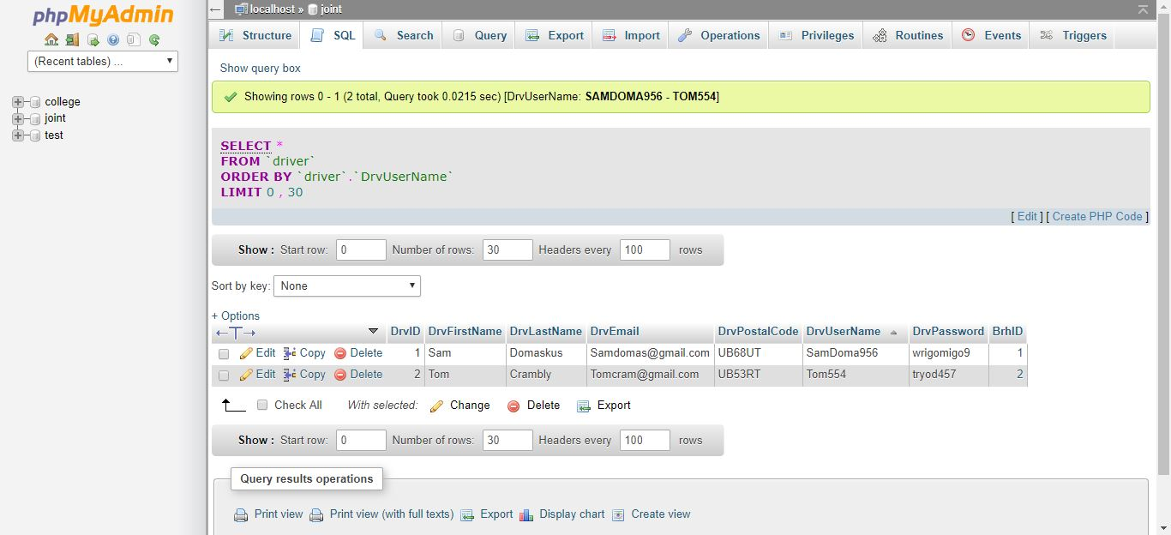

This Query tests the driver name form the driver table and finds the drivers username.

This above image demonstrates the working of the test.

**2) Simple Query 2 -**

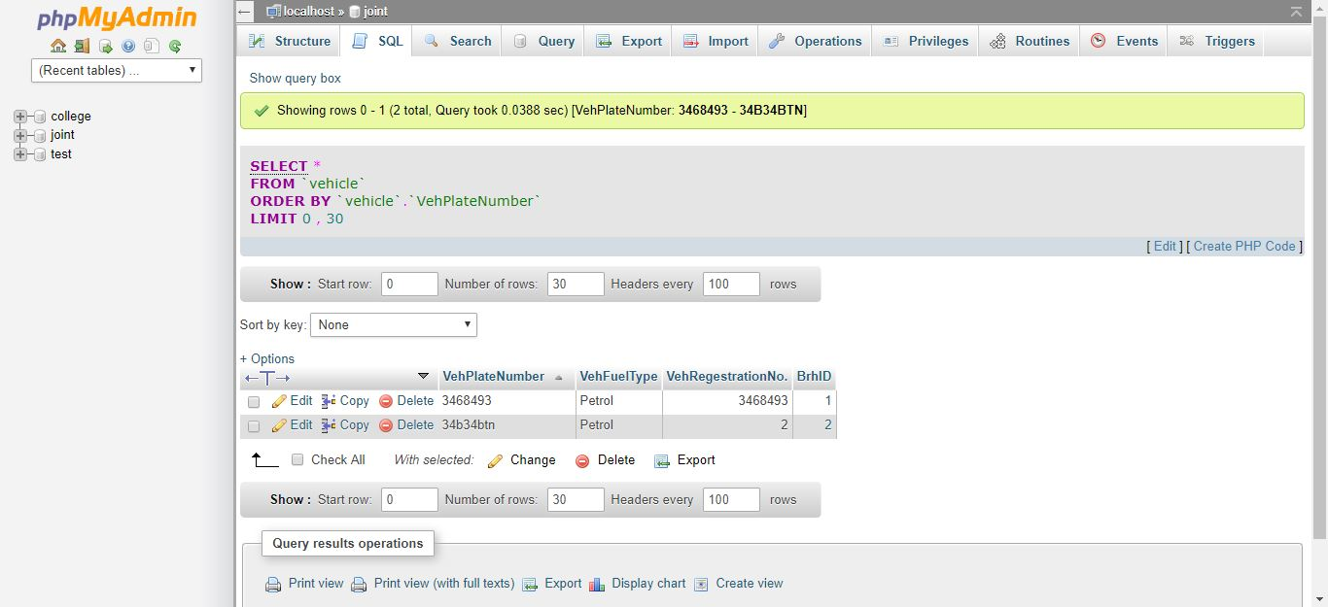

This Query tests the vehicle form the vehicle table and finds the vehicle number.

This above image demonstrates the working of the test.

**3) Simple Query 3 -**

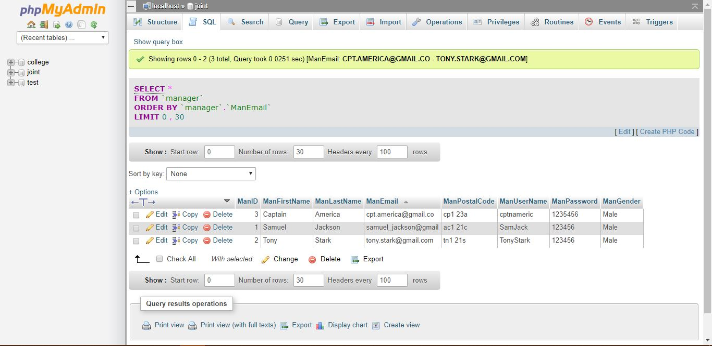

This Query tests the manager form the manager table and finds the managers email address. This above image demonstrates the working of the test.

**4) Simple Query 4 -**

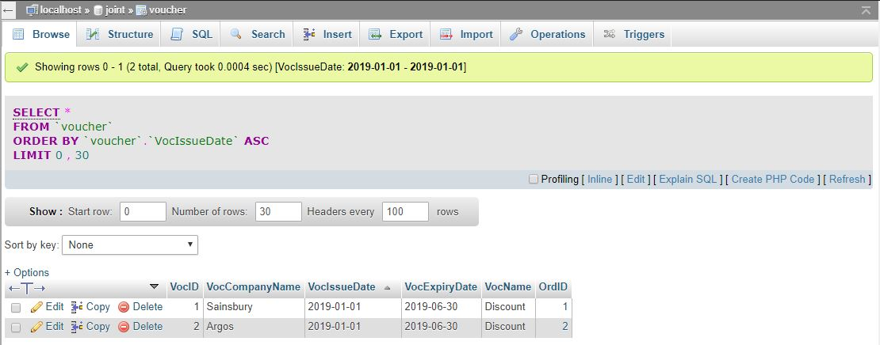

This Query tests the voucher form the voucher table and finds the voucher’s issue date.This above image demonstrates the working of the test.

**5) Simple Query 5 -**

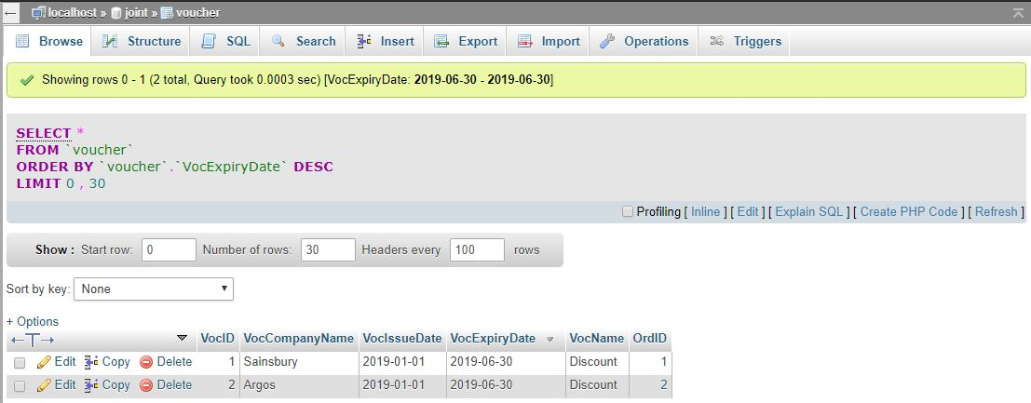

This Query tests the voucher form the voucher table and finds the voucher expiry date.This above image demonstrates the working of the test.

**6) Simple Query 6 -**

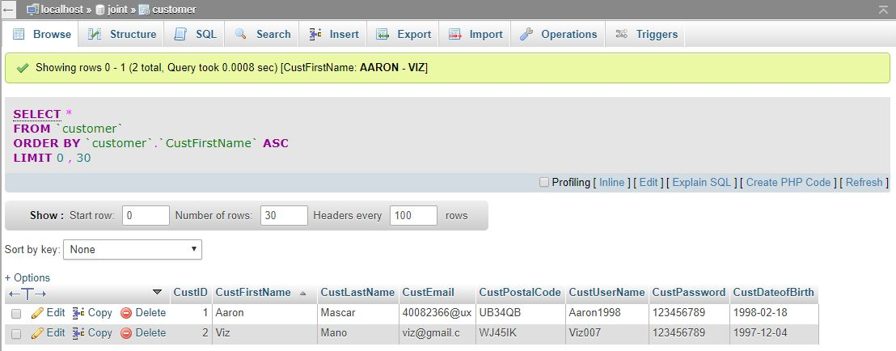

This Query tests the customer form the customer’s table and finds the customer’s first name.This above image demonstrates the working of the test.

**7) Simple Query 7 -**

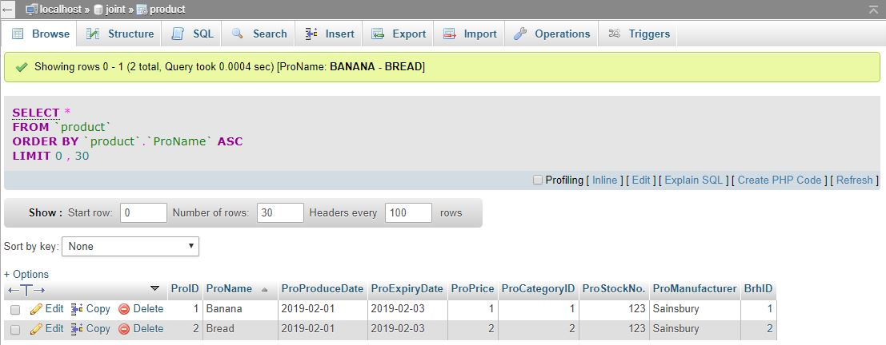

This Query tests the product form the product table and finds the product name.This above image demonstrates the working of the test.

**8) Simple Query 8 -**

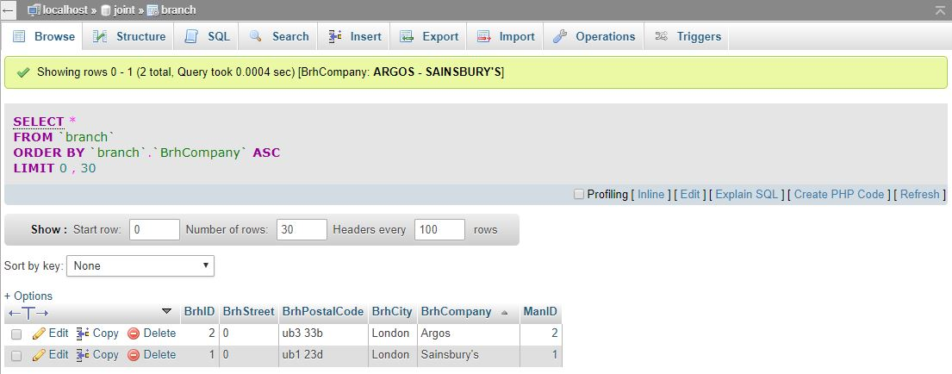

This Query tests the branch form the branch table and finds the branch company.This above image demonstrates the working of the test.

**9) Simple Query 9 -**

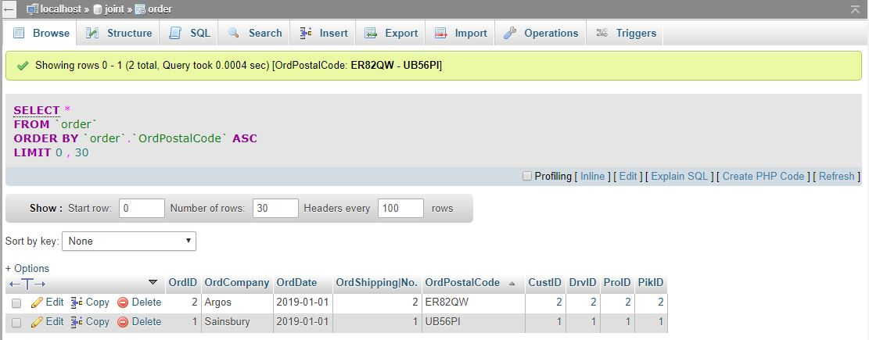

This Query tests the order form the order table and finds the order postal code.This above image demonstrates the working of the test.

**10) Simple Query 10 -**

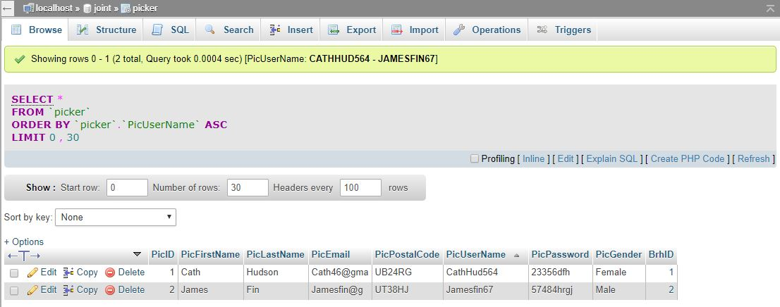

This Query tests the picker form the picker table and finds the picker’s username.This above image demonstrates the working of the test.

**11) Simple Query 11 -**

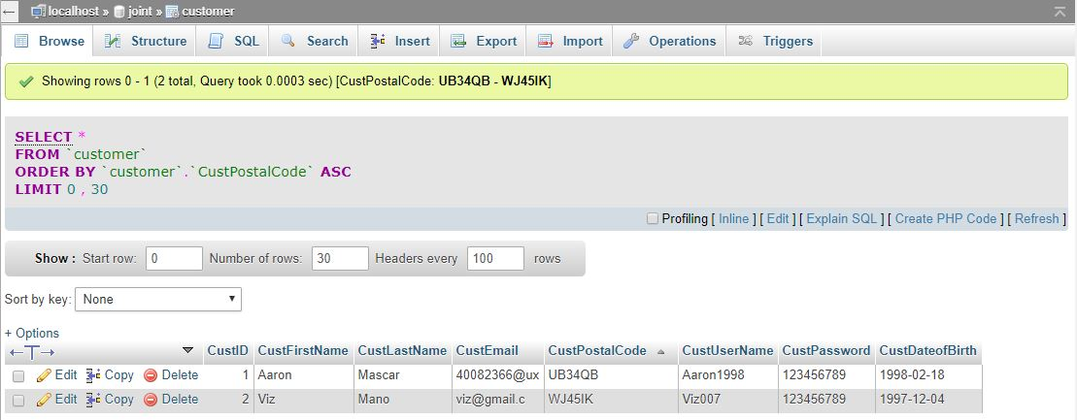

This Query tests the customer form the customer table and finds the customer’s postal code.This above image demonstrates the working of the test.

**12) Simple Query 12 -**

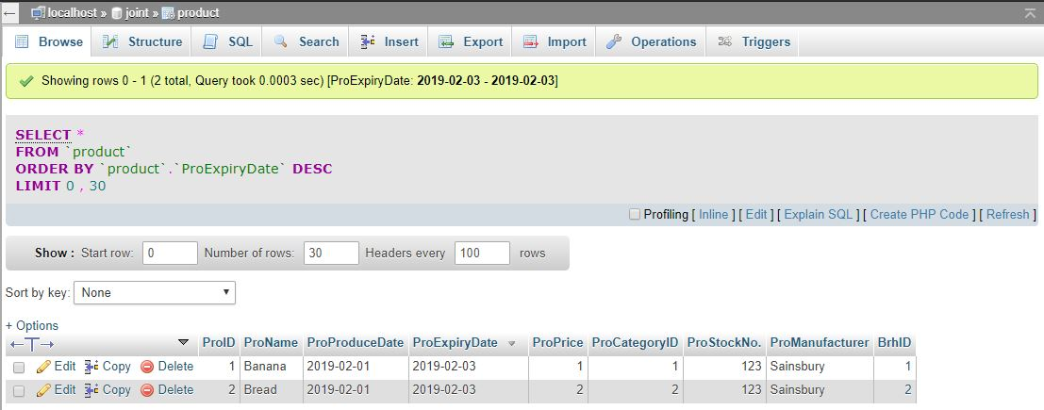

This Query tests the product form the product table and finds the product expiry date.This above image demonstrates the working of the test.

**Advanced Queries -**

**13) Simple Query 13 -**

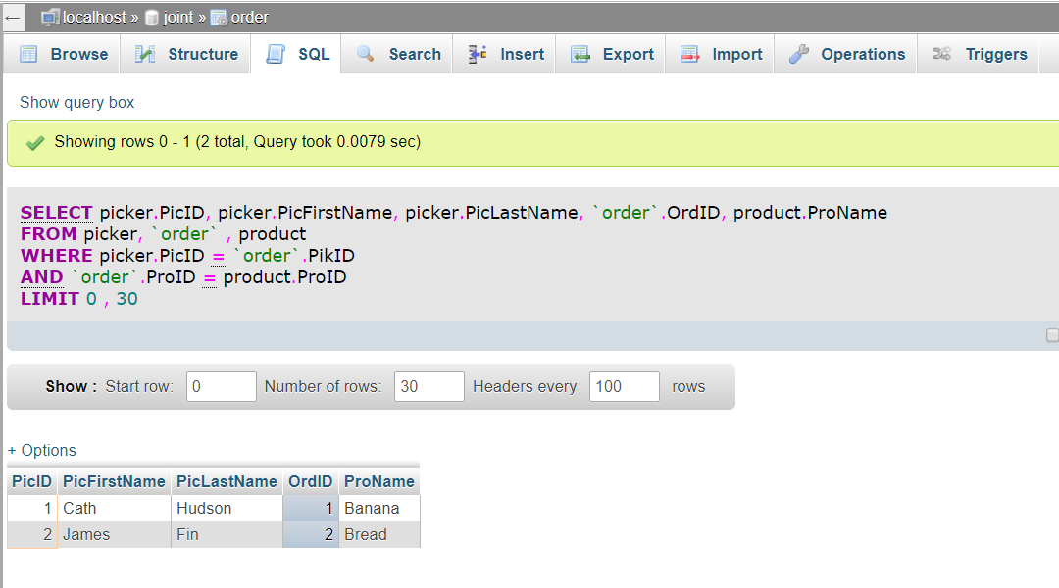

This Query tests the picker form the picker, order and product table and finds the picker’s ID, picker’s first name, piker’s last name, order ID, and product name.This above image demonstrates the working of the test.

**14) Simple Query 14 -**

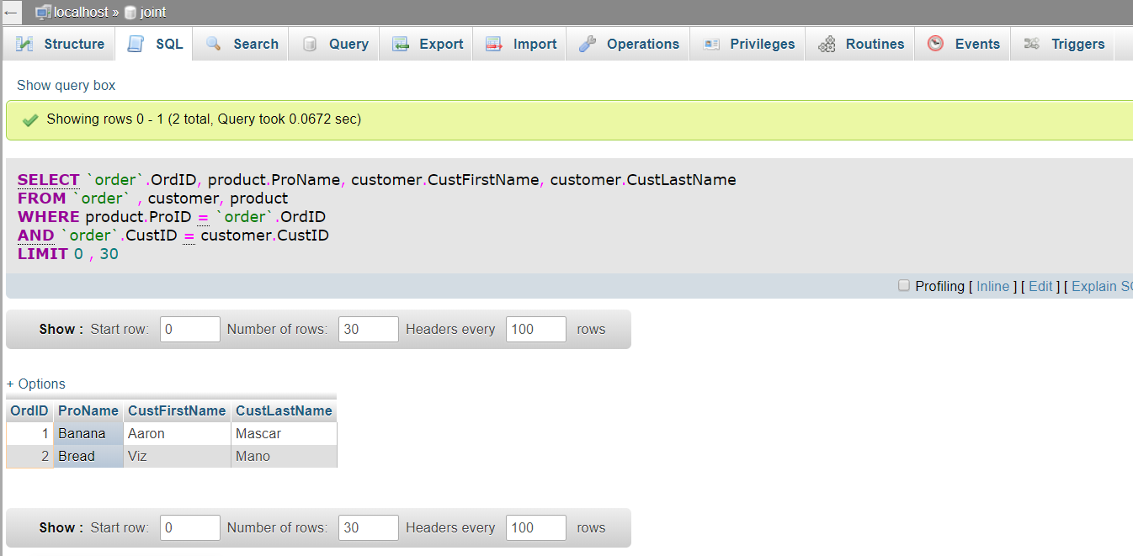

This Query tests the customer form the order, product and customer table and finds the order ID, product name, customer’s first name, customer’s last name.This above image demonstrates the working of the test.

**15) Simple Query 15 -**

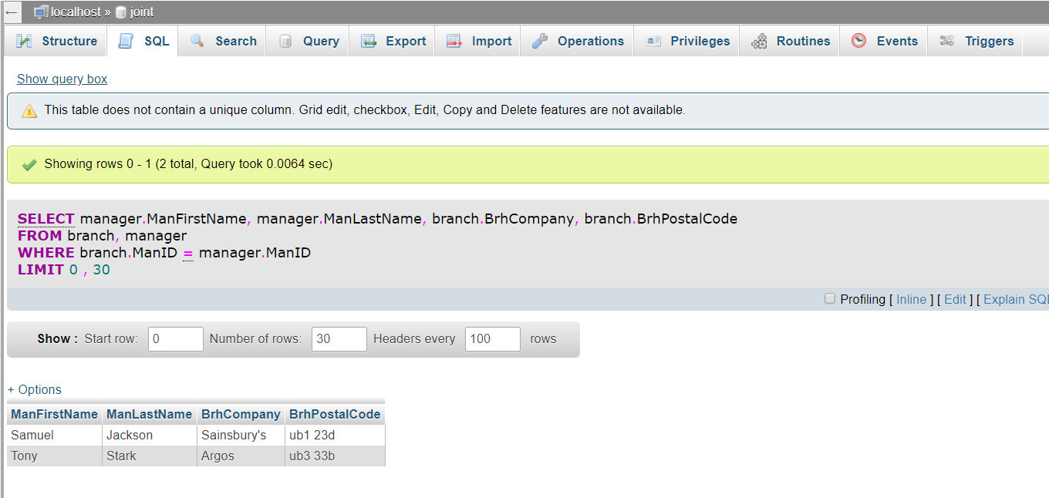

This Query tests the manager form the manager and branch table and finds the manager’s first name, manager’s last name, branch company and branch postal code.This above image demonstrates the working of the test.

**Conclusion -**

In conclusion this report shows how to analyse and shows how a database is used in then normalising information into somewhat of a better understanding table which list out the categories which contain primary keys and foreign keys which links with other interrelated tables. The ERD diagram is the product of the normalisation table which is more cleaner version of the normalisation table which hold information on orders from customers from both Sainsbury's and Argos. The Business process model Diagram is hypothetical representation of a Sainsbury's and Argos delivery cycle.